# Customize Launcher on Pico Device

## Applicable Products

Goblin; Pico Neo; Goblin 2;

## Modification Scheme

1. **Modification of AndroidManifest.xml**
2. Modify package name

Change the package name of launcher application to “**com.picovrtob.vrlauncher**”, and change VersionCode to 3000, as shown below:

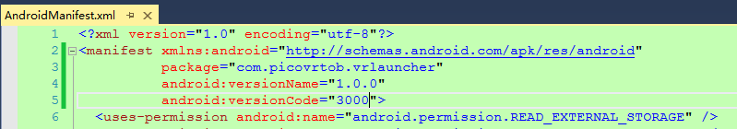

*Note: In all PicoNeo system and above PicoGoblinPUI version 2.3.0, when there is a launcher contains a package named “com.picovrtob.vrlauncher”, it is the system default launcher. To switch Picolauncher, users can modify home screen as PicoVRlauncher via 2D settings.*

1. Modify Main Activity

Change Main Activity as codes shown below:

<category android:name="android.intent.category.HOME" />

<category android:name="android.intent.category.DEFAULT" />

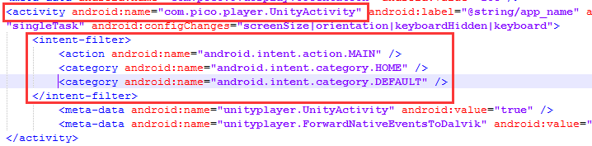

1. Unity Packaging

For Unity packaging, package name and version number of Player Settings must be consistent with AndroidManifest file.

1. **Install Package Signature**
2. Apply for an account

*Please contact Pico technician for account and password.*

1. Login Signature System

Open Pico online signature system ( <http://signature.picovr.com:9999/login> ), enter account and password to login. You will see "Signature List" after successful login.

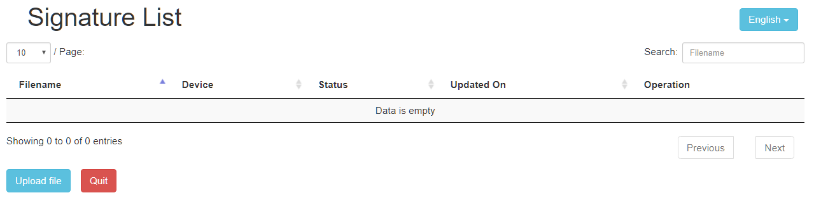

1. Upload Signature Application

Click on "Upload File", enter the upload file interface; Click "Select File" to select the application to be signed;

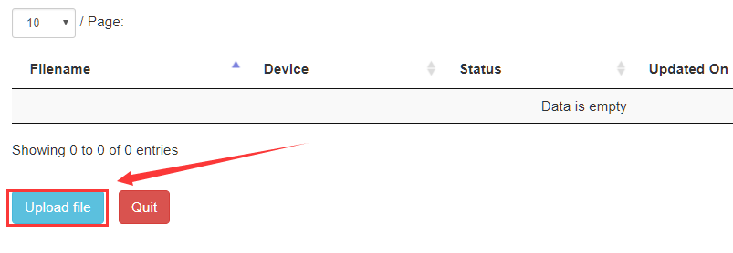

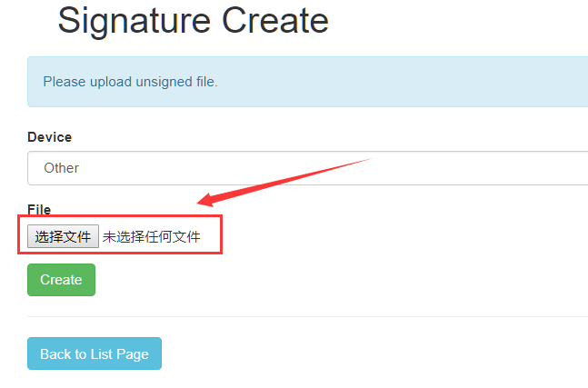

1. Select a signature device

Select “Other” then click “Create” button;

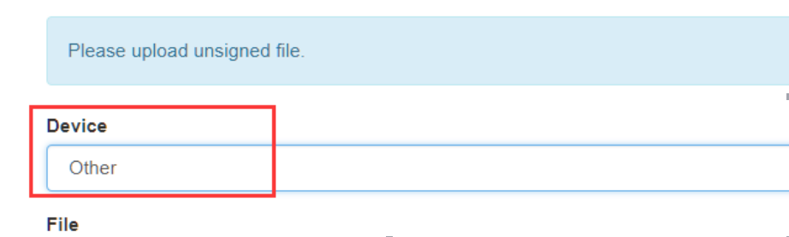

1. View Signature Results

Click "Back to list page"

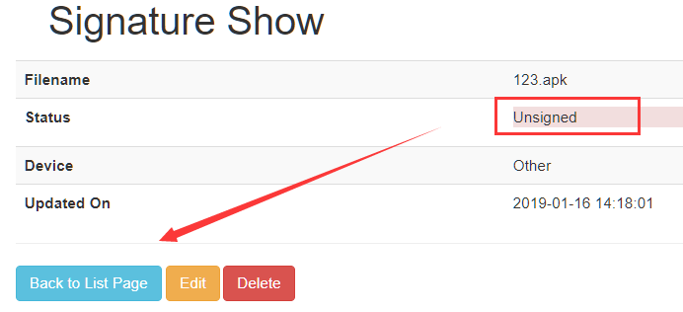

On the list page you can see the uploaded APK, and the status here is unsigned.

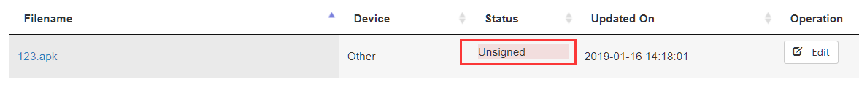

1. Get Signed APK

Normally in 5-10 minute system will complete signature automatically. Refresh list page, you can see the application signature status is "signed". Clicks"signed" to download signed APK.



Note: The launcher with package name “com.picovrtob.vrlauncher”, is the system default launcher. To switch launcher, users can change home screen to Pico default launcher or other custom launcher via 2D settings:

*In Goblin: Select system default launcher in “2D settings → home page” (To enter 2D settings, hold “Confirm” and “Volume -” as a combination key);*

*In PicoNeo and G2: 2D settings - Application - PicoVRlauncher - Is it a home screen - Choose home screen; (To enter 2D settings, hold “Confirm” and “Volume -” at the same time as a combination key);*